CPS 592

Interactive Media

Assignment 4

****

Team MEMBERS:

Qirui Li

Date:12/6/2017

Mesh without Shading shown as Figure.1

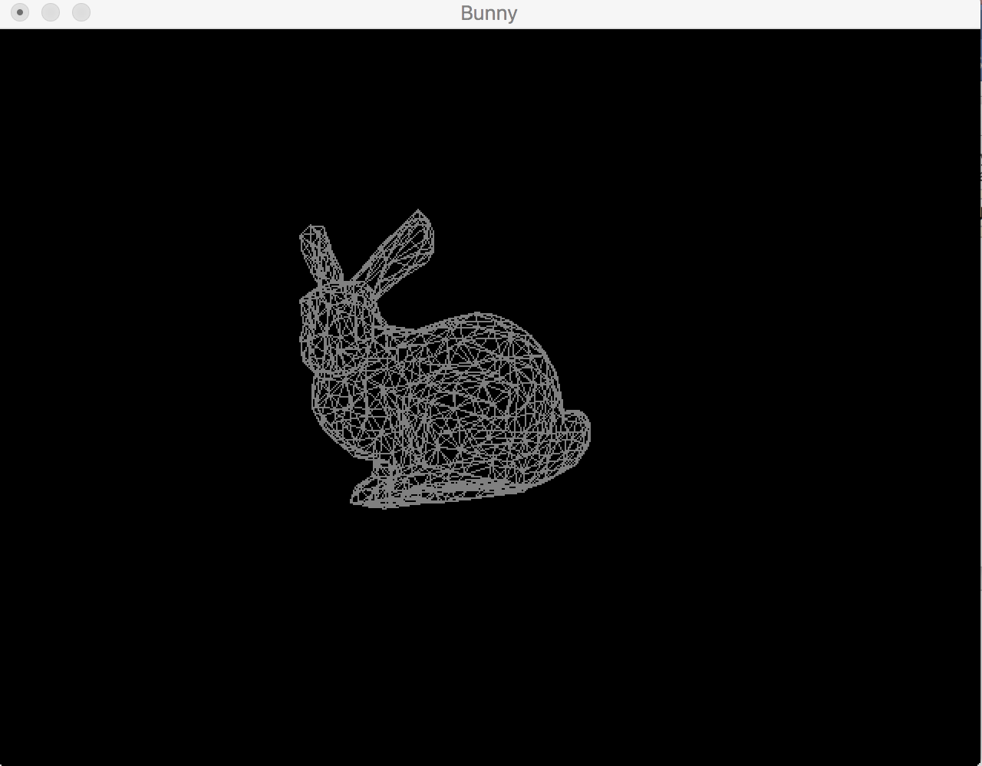

Figure.1

Mesh with Shading shown as Figure .2

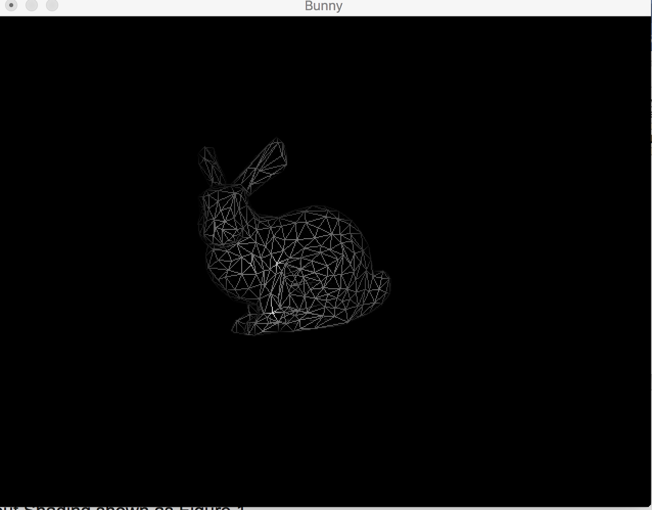

Figure.2

Press 0 to remove all the shading shown as Figure.3

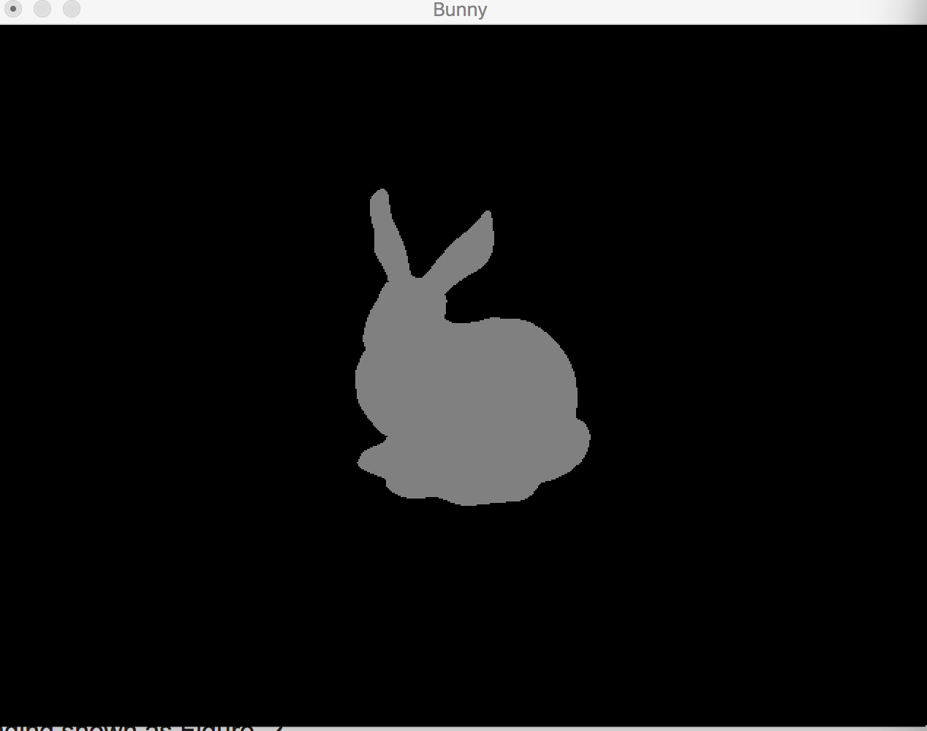

Figure.3

Press 1 to only show the diffuse and ambient(Plaster Version) shown as Figure.4

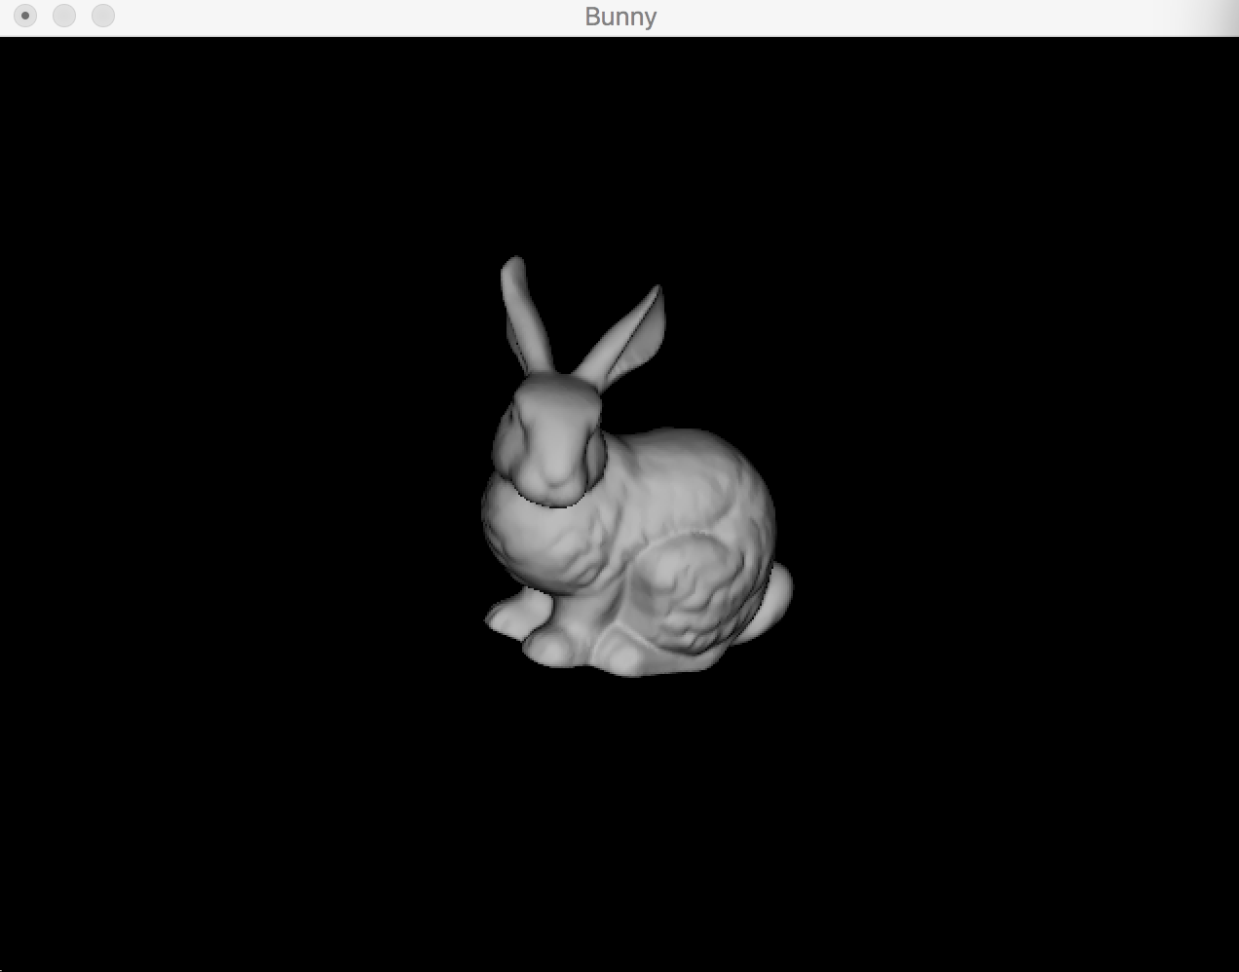

Figure.4

Press 2 to show the diffuse and ambient and phong(China Version) shown as Figure.5

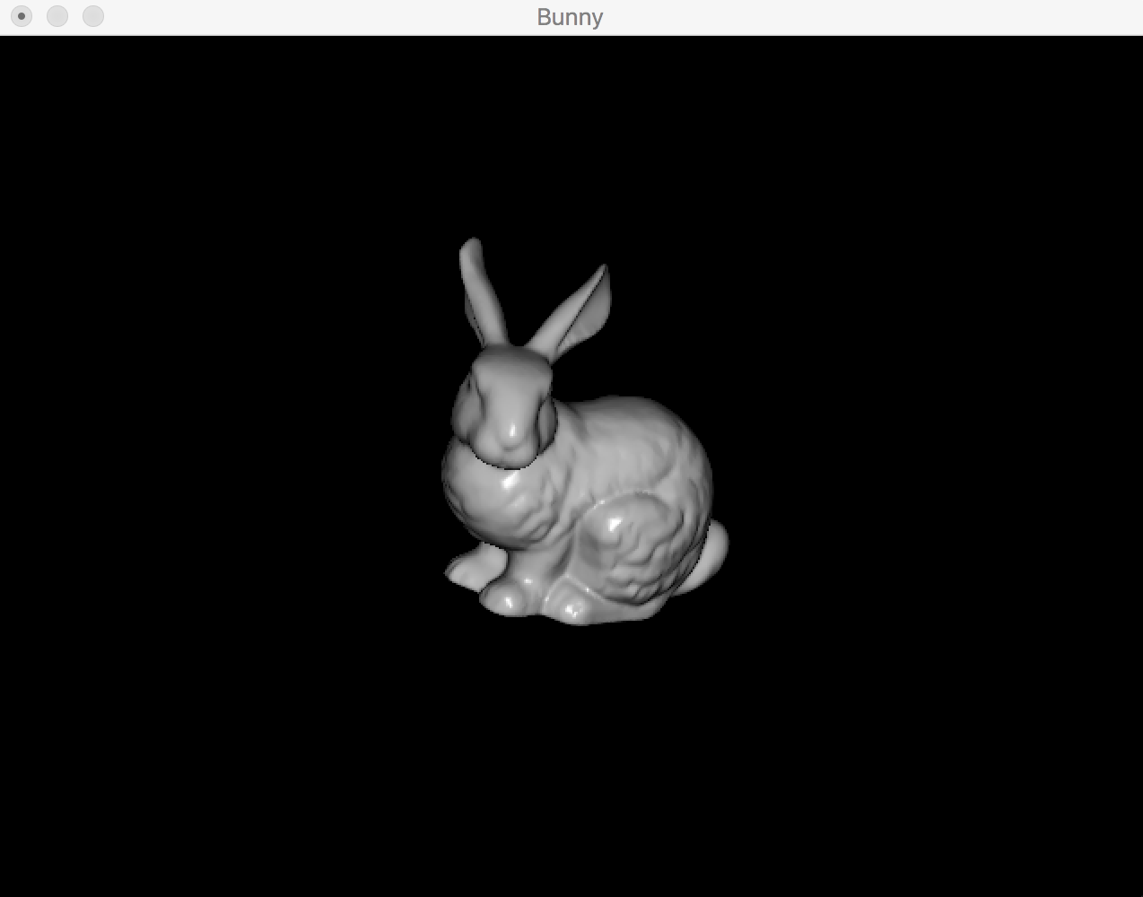

Figure.5

Press ‘G’ or ‘g’ to show the bunny as made of gold(Cold Version) shown as Figure.6

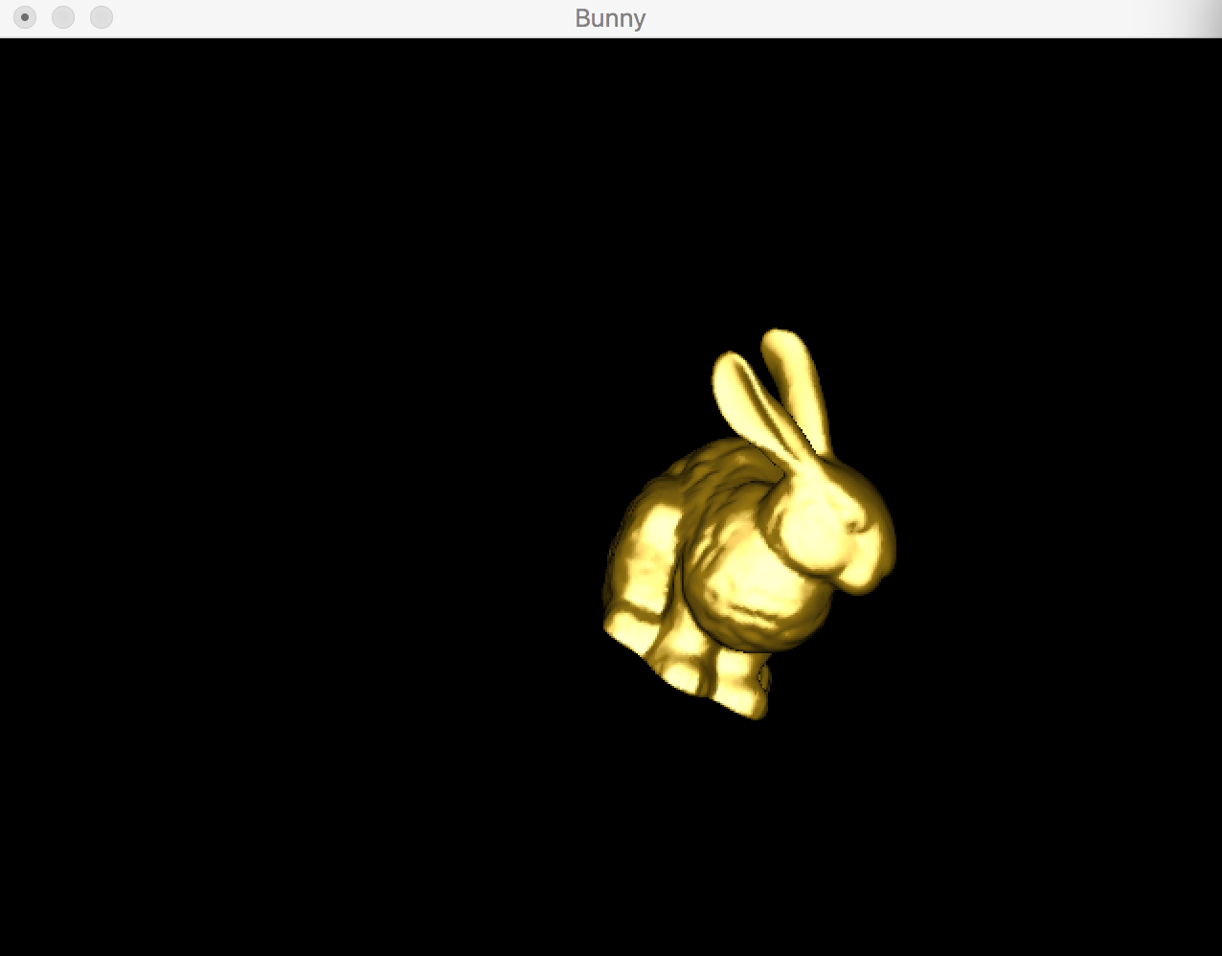

Figure.6

When in gold version but only display with diffuse and ambient color shown as Figure.7

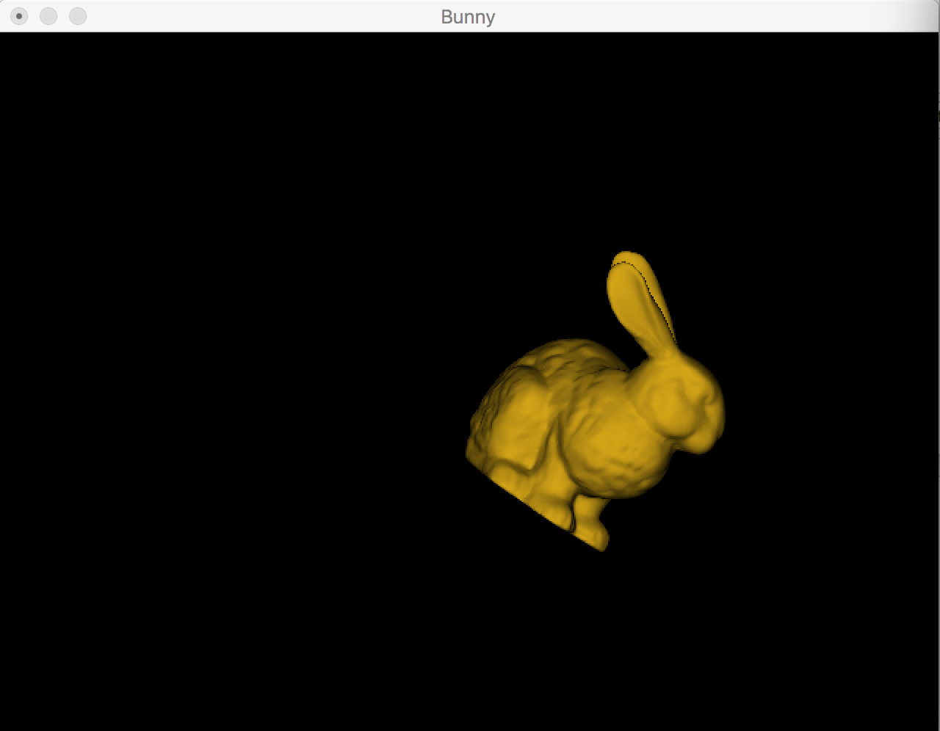

Figure.7